**Business Idea: SmartFarm - Revolutionizing Agriculture with Automation**

**Introduction**

Agriculture is the backbone of our civilization, providing food, feed, and fiber for an ever-growing global population. However, the agriculture sector faces numerous challenges, including labor shortages, fluctuating climate conditions, and the need for sustainable practices. The integration of automation technologies offers a solution to address these challenges while improving productivity and reducing costs.

**Current Situation**

In the current agricultural landscape, farmers rely heavily on manual labor for tasks such as planting, harvesting, and monitoring crop health. This reliance on human labor is not only expensive but also prone to inefficiencies. Moreover, unpredictable weather conditions and the need for precision in modern farming practices have made it increasingly challenging to maintain consistency and quality in crop production.

**How SmartFarm Will Help**

SmartFarm is a comprehensive automation solution designed to transform the agriculture sector. By harnessing cutting-edge technology, SmartFarm aims to:

1. Improve Efficiency: Reduce the dependency on manual labor, increasing efficiency and reducing production costs.

2. Enhance Crop Management: Implement precision agriculture techniques for more accurate and efficient resource allocation, optimizing crop growth and yield.

3. Minimize Environmental Impact: Integrate sustainable practices and reduce resource wastage, making agriculture more environmentally friendly.

**Proposed Model and Working**

SmartFarm will employ a combination of technologies, including robotics, IoT (Internet of Things), AI (Artificial Intelligence), and data analytics, to create a seamless automation platform for farmers.

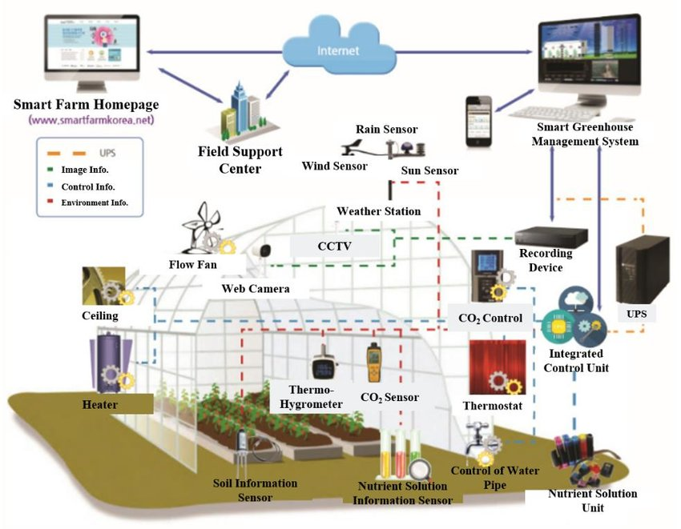

**1. Robotic Systems:** Autonomous drones and ground-based robots will be deployed for planting, monitoring, and harvesting crops. These robots will be equipped with AI vision systems to detect and respond to crop health issues.

**2. Sensors and IoT:** SmartFarm will utilize a network of sensors to monitor soil conditions, weather, and crop health in real-time. These data will be transmitted to a central platform for analysis.

**3. Data Analytics:** AI-driven analytics will process the data collected, offering insights into optimal planting times, irrigation needs, and early detection of diseases or pests.

**4. Mobile App:** Farmers will have access to a user-friendly mobile app, providing real-time updates on their farm's status and allowing for remote control of robotic systems.

**Technical Knowledge and Skills Needed**

To implement SmartFarm, the following technical knowledge and skills will be required:

1. Robotics Engineering

2. IoT Systems Development

3. AI and Machine Learning

4. Data Analytics and Visualization

5. Software Development (for mobile app and central platform)

6. Agricultural Expertise (to adapt to specific crop requirements)

7. Hardware Integration

In conclusion, SmartFarm offers a revolutionary solution to the challenges faced by the agriculture sector. By automating tasks, optimizing resource allocation, and incorporating sustainable practices, SmartFarm has the potential to significantly increase productivity while minimizing costs and environmental impact. This business idea harnesses the power of modern technology to create a more efficient and sustainable future for agriculture.